Problem statement 01:

1.

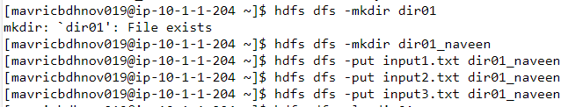

2.

3.

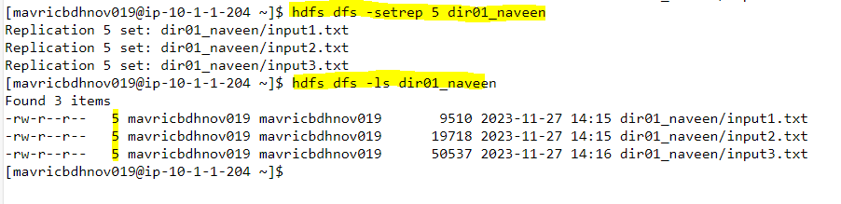

4.

